Default Report  
*Music Theory App*  
**July 26th 2022, 8:14 am MDT**

**Q1 - How old are you?**

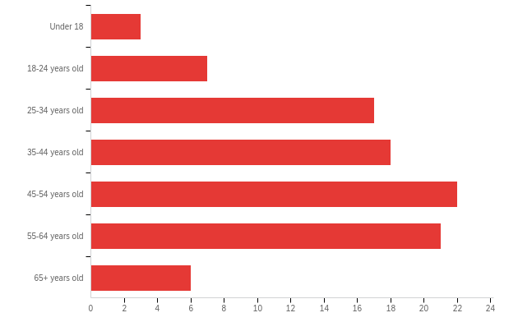

|  |  |  |  |  |  |  |  |
| --- | --- | --- | --- | --- | --- | --- | --- |
| # | Field | Minimum | Maximum | Mean | Std Deviation | Variance | Count |
| 1 | How old are you? | 1.00 | 7.00 | 4.45 | 1.51 | 2.27 | 94 |

|  |  |  |  |
| --- | --- | --- | --- |
| # | Answer | % | Count |
| 1 | Under 18 | 3.19% | 3 |
| 2 | 18-24 years old | 7.45% | 7 |
| 3 | 25-34 years old | 18.09% | 17 |
| 4 | 35-44 years old | 19.15% | 18 |
| 5 | 45-54 years old | 23.40% | 22 |
| 6 | 55-64 years old | 22.34% | 21 |
| 7 | 65+ years old | 6.38% | 6 |
|  | Total | 100% | 94 |

**Q2 - 2. Do you teach or have you ever taught music in any capacity?**

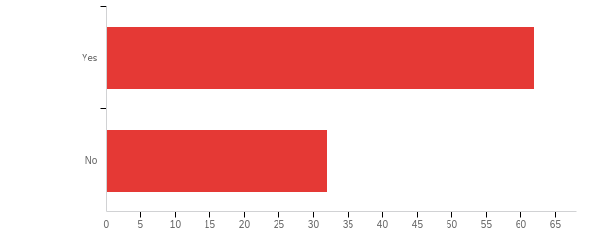

|  |  |  |  |  |  |  |  |
| --- | --- | --- | --- | --- | --- | --- | --- |
| # | Field | Minimum | Maximum | Mean | Std Deviation | Variance | Count |
| 1 | 2. Do you teach or have you ever taught music in any capacity? | 1.00 | 2.00 | 1.34 | 0.47 | 0.22 | 94 |

|  |  |  |  |
| --- | --- | --- | --- |
| # | Answer | % | Count |
| 1 | Yes | 65.96% | 62 |
| 2 | No | 34.04% | 32 |
|  | Total | 100% | 94 |

**Q3 - 3. Do you play any musical instruments at any level?**

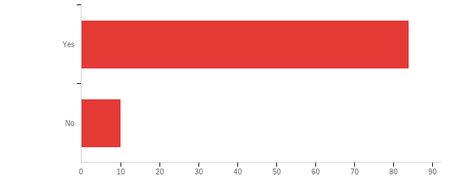

|  |  |  |  |  |  |  |  |
| --- | --- | --- | --- | --- | --- | --- | --- |
| # | Field | Minimum | Maximum | Mean | Std Deviation | Variance | Count |
| 1 | 3. Do you play any musical instruments at any level? | 1.00 | 2.00 | 1.11 | 0.31 | 0.10 | 94 |

|  |  |  |  |
| --- | --- | --- | --- |
| # | Answer | % | Count |
| 1 | Yes | 89.36% | 84 |
| 2 | No | 10.64% | 10 |
|  | Total | 100% | 94 |

**Q4 - If yes, what instrument(s) do you play?**

|  |
| --- |
| If yes, what instrument(s) do you play? |
| Double bass, recorders, flute, guitar |
| Trumpet |
| Accordion |
| Guitar, Bouzouki, Blues Harp |
| Woodwind, piano, Lever Harp |
| Piano, bagpipes, harp, accordion, ukulele, voice |
| Tuba |
| Piano |
| Flute piano drums voice |
| All the percussion family, piano |
| Piano |
| Guitar |
| Violin viola pisno |
| Clarinet |
| clarinet, recorder, violin (fiddle) |
| French horn |
| Flute, piano |
| Low brass |
| Piano |
| Piano, Percussion and Voice |
| French horn, trumpet/cornet, trombone, tuba, piano, violin, flute, double bass, recorder |
| Bass |
| Euphonium, piano, drum kit, percussion. |
| Piano (Grade 5), Accordion, Organ, Percussion, Guitar, Bass etc. |
| Piano, saxophone, guitar, bass, |
| Clarinet |
| Piano |
| Piano, saxophone |
| Piano alto sax clarinet bagpipes guitar kit bass ukulele |
| Clarinet |
| Piano, violin, drum kit, guitar, bass guitar, accordion, ukulele |
| Flute, oboe, clarinet, piano and keyboards including organ, voice, recorders, guitar, drum kit, tuned percussion, fiddle |
| Piano, flute, bagpipes |
| Piano, violin, drum kit |
| Violin Piano Clarinet |
| Violin and piano |
| Piano |
| Piano |
| Accordion, piano |
| Brass/Wind |
| Piano |
| Acoustic/Electric guitar, Drumkit |
| Piano voice |
| Saxophone, guitar, piano |
| Clarinet, saxophone, piano |
| Piano and violin |
| Guitar, keyboards, bass, accordion, bagpipes |
| Oboe, trombone, cello, piano, drum kit, hand bells |
| Clarinet and pianos |
| Piano |
| Accordion and flute |
| Trumpet, piano, guitar, bass, recorder |
| Piano, clarinet, trombone |
| Violin and piano |
| Piano, trumpet |
| Piano, clarinet, trumpet |
| Flute, piano, violin |
| Saxophone, clarinet, flute, organ, piano |
| Piano |
| Voice, piano |
| Percussion |
| Piano, violin, percussion, voice |
| Piano |
| violin, guitar, piano, cello |
| Flute piano tenor sax percussion violin |
| Flute |
| Piano |
| Sax, brass |
| In what sense, "play"? I've played piano, organ, clarinet, saxophone, harpsichord, guitar, bass guitar, drum kit, voice, trumpet |
| Violin |
| Violin, viola, cello, double bass, piano, clarinet, vocal |
| Oboe piano |
| Piano, clarinet, voice |
| Guitar |
| Flute piano guitar ukulele |
| guitar and harmonica |
| Drums |
| Keyboard |
| Guitar, bass |
| Drums guitar piano |
| Piano guitar |
| Piano |
| Guitar |
| Geetur |

**Q5 - If you play an instrument, are you self-taught or do/did you get lessons from an instructor?**

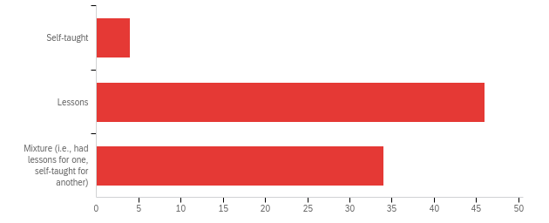

|  |  |  |  |  |  |  |  |
| --- | --- | --- | --- | --- | --- | --- | --- |
| # | Field | Minimum | Maximum | Mean | Std Deviation | Variance | Count |
| 1 | If you play an instrument, are you self-taught or do/did you get lessons from an instructor? | 1.00 | 3.00 | 2.36 | 0.57 | 0.32 | 84 |

|  |  |  |  |
| --- | --- | --- | --- |
| # | Answer | % | Count |
| 1 | Self-taught | 4.76% | 4 |
| 2 | Lessons | 54.76% | 46 |
| 3 | Mixture (i.e., had lessons for one, self-taught for another) | 40.48% | 34 |
|  | Total | 100% | 84 |

**Q6 - How would you describe your current music theory knowledge?**

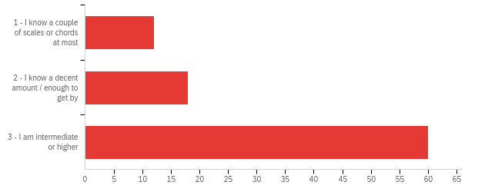

|  |  |  |  |  |  |  |  |
| --- | --- | --- | --- | --- | --- | --- | --- |
| # | Field | Minimum | Maximum | Mean | Std Deviation | Variance | Count |
| 1 | How would you describe your current music theory knowledge? | 1.00 | 3.00 | 2.53 | 0.72 | 0.52 | 90 |

|  |  |  |  |
| --- | --- | --- | --- |
| # | Answer | % | Count |
| 1 | 1 - I know a couple of scales or chords at most | 13.33% | 12 |
| 2 | 2 - I know a decent amount / enough to get by | 20.00% | 18 |
| 3 | 3 - I am intermediate or higher | 66.67% | 60 |
|  | Total | 100% | 90 |

**Q7 - Would you be interested in an app to help you learn music theory?**

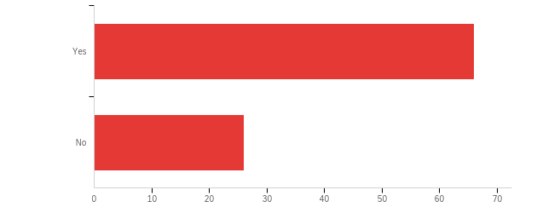

|  |  |  |  |  |  |  |  |
| --- | --- | --- | --- | --- | --- | --- | --- |
| # | Field | Minimum | Maximum | Mean | Std Deviation | Variance | Count |
| 1 | Would you be interested in an app to help you learn music theory? | 1.00 | 2.00 | 1.28 | 0.45 | 0.20 | 92 |

|  |  |  |  |
| --- | --- | --- | --- |
| # | Answer | % | Count |
| 1 | Yes | 71.74% | 66 |
| 2 | No | 28.26% | 26 |
|  | Total | 100% | 92 |

**Q8 - What would be your main reason for wanting to learn music theory?**

|  |
| --- |
| What would be your main reason for wanting to learn music theory? |
| Help my kids, access to higher exams |
| Help my pupils. |
| To help me play better |
| To refresh knowledge but also to have something that students can access easily. |
| For students |
| For band practice |
| An app that would be a good teaching resource would be helpful ! |
| I don't need it but it would maybe hep students |
| Expand my own knowledge in the area! |
| Appreciation |
| Self improvement |
| Help my kids |
| refresher course/teaching |
| To use with pupils. |
| Better understand of chords to help piano playing |
| For my pupils/students to use |
| It would be to motivate my pupils |
| For my students |
| I know theory but I’m always looking for new ways for my pupils to learn theory and they tend to respond well to apps |
| Better communication with other musicians |
| Share the app with my pupils to help with their SQA exams. |
| Probably to understand different pieces of music - how the notes interact with each other, unique time divisions etc. |
| Share with students |
| Improving my playing |
| To deepen my understanding of what I’m playing. |
| To support my pupils |
| To use it as a tool within the classroom |
| I would get my pupils to use it |
| I'm a teacher who would really like this for my pupils. My theory knowledge is at degree level. |
| Help my kids learn; improve my ability to improvise |
| For pupils of mine |
| For fun in spare time |
| Expanding my own knowledge - continued learning |
| To improve my playing |
| To help my theory pupils- they could use it |
| To improve my knowledge of the guitar fretboard and be able to use scales more effectively in my playing |
| To play better |
| Improve my knowledge |
| New songwriting ideas |
| Easy access to theory |
| Help my son learn guitar |
| Love learning |
| Not for me personally but for my students |
| I have music theory to grade 7 trinity and Abrsm level, I will always want to have something to keep my knowledge sharp, would be great for my students also! |
| To pass exam |
| Not to help me, but to help pupils would be good |
| For pupils |
| It enhances your playing and understanding |
| To share with pupils |
| Pass onto students studying music at school. This could be really helpful. |
| Improve ability and understand for ensemble playing |
| To keep my knowledge up to date |
| Improvisation. |
| I would find it useful for my pupils to have something which would help them learn more interactively. |
| To share with pupils |
| As a teaching tool |
| To understand the music i am playing better as well as create better music |
| To help with my playing and understanding |
| to improve my playing |
| As a drummer, i don't tend to use melodic and harmonic theory day to day. I'd like to learn it though. |
| For family fun |
| To be able to play the keyboard better. |
| Deeper understanding |
| Knowing theory makes it easier to learn practically |
| For teaching purposes |
| Furthering music theory knowledge will increase my music reading ability for learning new songs |
| Playing music |
| Better understanding of whst im playing |

**Q9 - How important do you think it is for musicians to have a well-rounded knowledge of theory?**

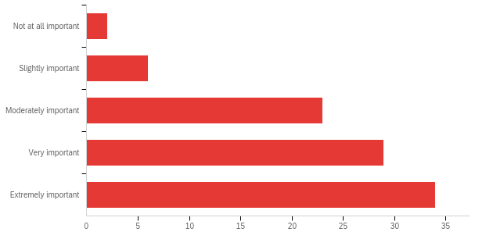

|  |  |  |  |  |  |  |  |
| --- | --- | --- | --- | --- | --- | --- | --- |
| # | Field | Minimum | Maximum | Mean | Std Deviation | Variance | Count |
| 1 | How important do you think it is for musicians to have a well-rounded knowledge of theory? | 1.00 | 5.00 | 3.93 | 1.02 | 1.05 | 94 |

|  |  |  |  |
| --- | --- | --- | --- |
| # | Answer | % | Count |
| 1 | Not at all important | 2.13% | 2 |
| 2 | Slightly important | 6.38% | 6 |
| 3 | Moderately important | 24.47% | 23 |
| 4 | Very important | 30.85% | 29 |
| 5 | Extremely important | 36.17% | 34 |
|  | Total | 100% | 94 |

**Q10 - How long would you aim to use a music theory learning app each day?**

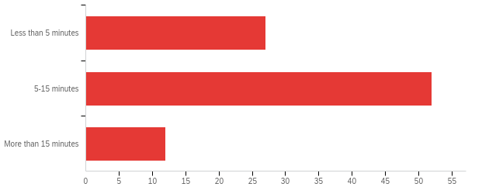

|  |  |  |  |  |  |  |  |
| --- | --- | --- | --- | --- | --- | --- | --- |
| # | Field | Minimum | Maximum | Mean | Std Deviation | Variance | Count |
| 1 | How long would you aim to use a music theory learning app each day? | 1.00 | 3.00 | 1.84 | 0.63 | 0.40 | 91 |

|  |  |  |  |
| --- | --- | --- | --- |
| # | Answer | % | Count |
| 1 | Less than 5 minutes | 29.67% | 27 |
| 2 | 5-15 minutes | 57.14% | 52 |
| 3 | More than 15 minutes | 13.19% | 12 |
|  | Total | 100% | 91 |

**Q11 - Are there any particular features you would want from such an app?**

|  |
| --- |
| Are there any particular features you would want from such an app? |
| Track progress |
| Ability to select a grade/level to work on. Quizzes or game style quizzes to keep users interested. Earn points, etc. UK and US notation equivalents. Inclued aural as well as written examples. Users coukd play in answers using a built in piano. Could have a social function or way of sharing results? |
| Base clef note names |
| Note and symbol naming, chord identification, quizzes on common Italian terms and their use, fill in the blanks but with missing notes |
| Always always link it to sounds; without that, music theory is tedious and boring. |
| Music appreciation |
| Specific examples from well known music |
| chord structures, intervals, cadences |
| Game like. |
| Don't know enough |
| Linked to ABRSM grades |
| Needs to be fun and motivational. Divided into very small bites of learning and revision. |
| Circle of Fifths and fun interactive games |
| Graded exercises. Clear instructions and explanations. I’d want it to be directly related to ABRSM/Trinity theory at their graded levels |
| Progress bar. A little “cheer” noise when you get something right like they used to play on EasyJet flights when it landed. |
| Easy to navigate. bite sized learning, quizzes with feedback/marks. Sections linked to the SQA levels with relevant content to these levels, and for further up the levels, quizzes that incorporate content from the lower levels too. |
| I'd like to see some stuff on different temperaments, microtones, negative harmony etc. Also some stuff on music from around the world eg India, China, South America etc - learning about how people from different cultures think of music. |
| Musical examples then quizzes |
| Different rythms |
| All connected to sqa requirements with practise qu too |
| Theory up to grade 5 level with feedback and printout features. Being able to use online with chromebooks would be great. |
| Chords |
| Fun |
| Progressive, repetitive |
| N/A |
| Make learning scales easy |
| Audio examples of notes/chords |
| Suitable for young children |
| Something that's good for all ages of students to use. |
| Adaptive difficulty |
| Different level options |
| Practise example questions |
| Tailored to exam board syllabuses |
| Ease of use |
| Feedback |
| Interval, scales and chord recognition. Basically anything that would support the teaching of N5, Higher and Advanced Higher Literacy |
| User friendly, simple to look at and use. Quizzes to test knowledge |
| Interactive |
| Duolingo style |
| To be in line with either ABRSM or trinity theory grades. To be user-friendly. Theory books are very wordy! It would need to be user friendly from young beginners to older students. |
| Audio tests for intervals |
| Clear & logical progression |
| Quiz questions |
| understanding guitar notation |
| Tests, progress markers |
| Sound & verbal instructions (wear heading aids!) |
| Quiz |
| Listening exercises like listening to an excerpt of music and identifying features within the music. |
| Immediate showing if your answer is correct and you if not pointers to getting the correct answer. |
| Recognition of day streaks learning music theory, increasing difficulty with pop quizzes every x number of lessons (similar to Duolingo) |
| Tuning instruments |
| Games |